Goals:

* ~~Making the claw on the arm grasp onto mobile goals~~
* Making a clamp that can drag mobile goals
* Adding zip ties to attach the motors to the chassis
* Testing the Inertia Sensor for the autonomous period using the Moby Robots (run tests)
* Testing the GPS Sensor for the programming skills challenge using the Moby Robots (configure & test)
* Develop game strategies during the driver-controlled period
* Increase torque of arm with gear ratio or slower power
* Increase torque of claw with gear ratio or slower power
* Order products

Today, Andrew attended the meeting. He organized the toolbox as we had parts in multiple places and in inconsistent groups. He also moved the motor of the claw up because it would hit the wheels and cause match-affecting friction.

Identify the Problem: When the robot would pick up the mobile goal, it would fall off. The mobile goal was being carred by a single fork on the top. We needed something to be on the bottom.

Brainstorm Solutions:

1. Use another fork on the bottom of the claw
2. Use an angle as the base for the mobile goal
3. Use an angle as the base and a fork on top of it

Select the Best Solution: Andrew chose solution 2. The flat angled base would lift the mobile goal on the bottom while the fork kept it on the base.

Build and Program the Solution: Andrew attached the angled base on the bottom of the arms.

Test the Solution: When picking up the mobile goal, the angled base on the bottom of the arms would lift it from the bottom and the fork would keep it in place. The next photos will show how the robot picks up a mobile goal.

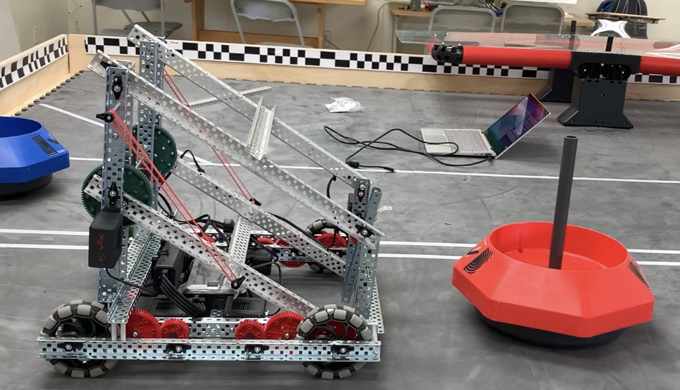

The robot will approach mobile goal.

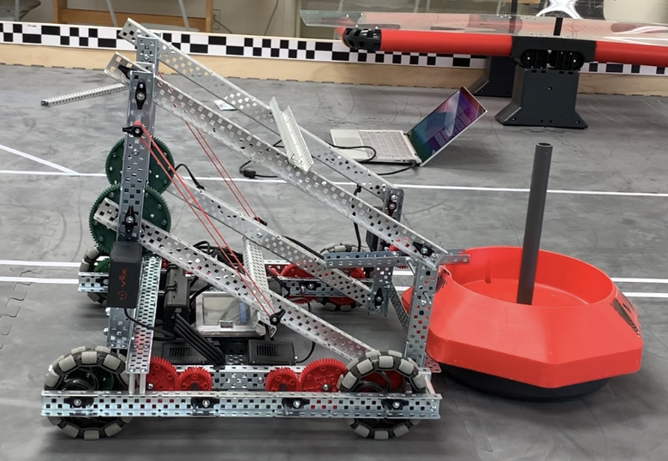

The robot will grab onto the mobile goal. Its angled bottom base would go under the mobile goal while the top fork would clamp onto the side of the mobile goal.

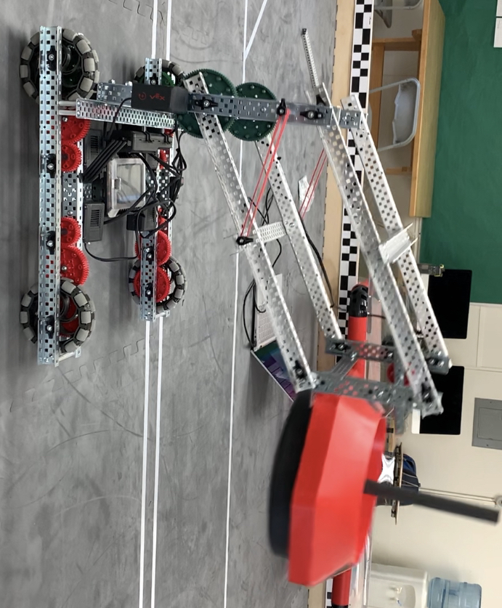

The robot will pick up the mobile goal.

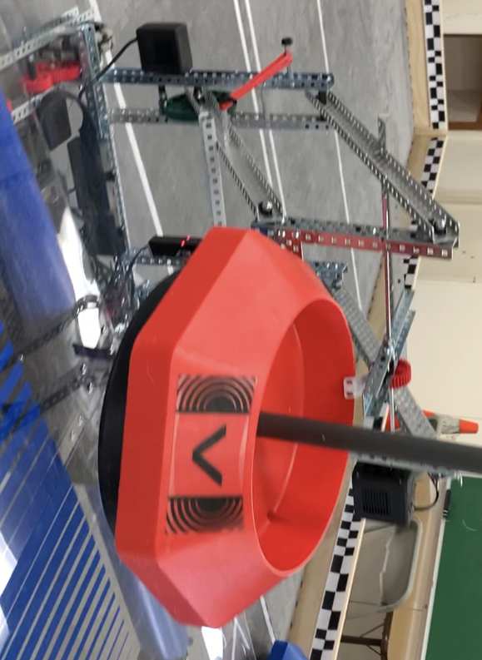

The robot will position the mobile goal over a target to drop.

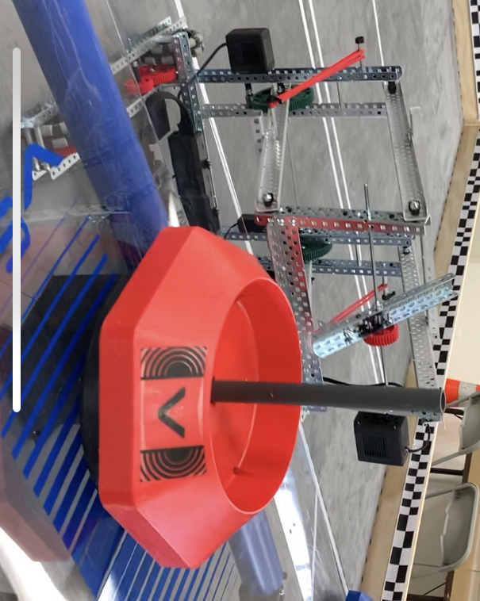

The robot will release the clamp and lower the arm. This would drop the mobile goal over the target.

The robot was able to pick up the alliance mobile goals and move around the field. However, when it picked up the neutral mobile goals, which were heavier, or if it picked up a mobile goal from an angle or non-flat area, it would drop it.

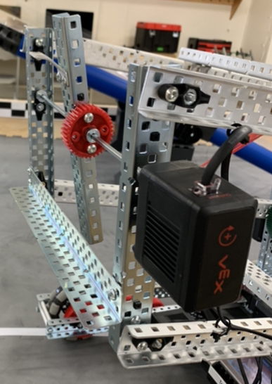

Closeup of claw.

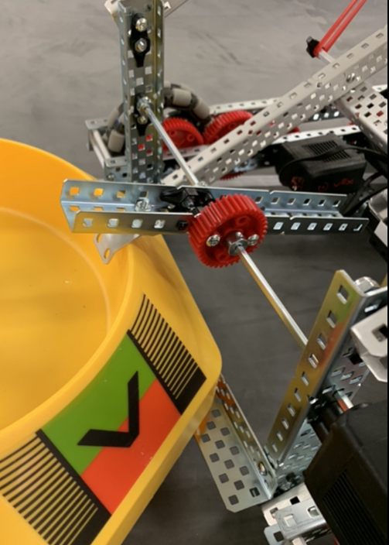

Closeup of claw grasping a mobile goal.

Identify the Problem: The mobile goal would fall off the arm if it was too heavy or picked up from an angle.

Brainstorm Solutions:

1. Attach a fork on top of the bottom angled base
2. Replaced the bottom angled base with a fork
3. Attach rubber stoppers on the fork to create more friction.

Select the Best Solution: Andrew selected solution 1 as the form would go in the bottom of the mobile goal preventing it from falling unless the arm let go of it. Solution 2 would prevent the mobile goal from falling but then it would be angled. If we tried to drop the mobile goal, it could tip over. Solution 3 was not possible as we did not have any rubber stoppers and it would take a week for them to be shipped.

Build and Program the Solution: Andrew attached the fork onto the bottom angled base.

Test the Solution: The robot successfully picked up all mobile goals, moved around the field, and drop them without an angle or them tipping over.

After many tests, the arm of the robot would become loose. This is because the nuts that are being used are hex nuts instead of nylock nuts, which were stronger. All of the robot’s hex nuts had to be replaced with nylock nuts, but this would take a long time.

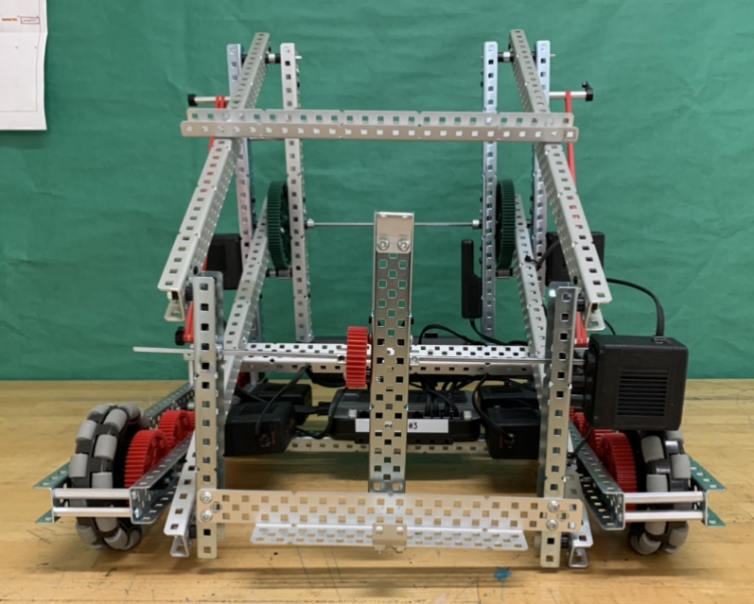

Front view of Blam Bot.

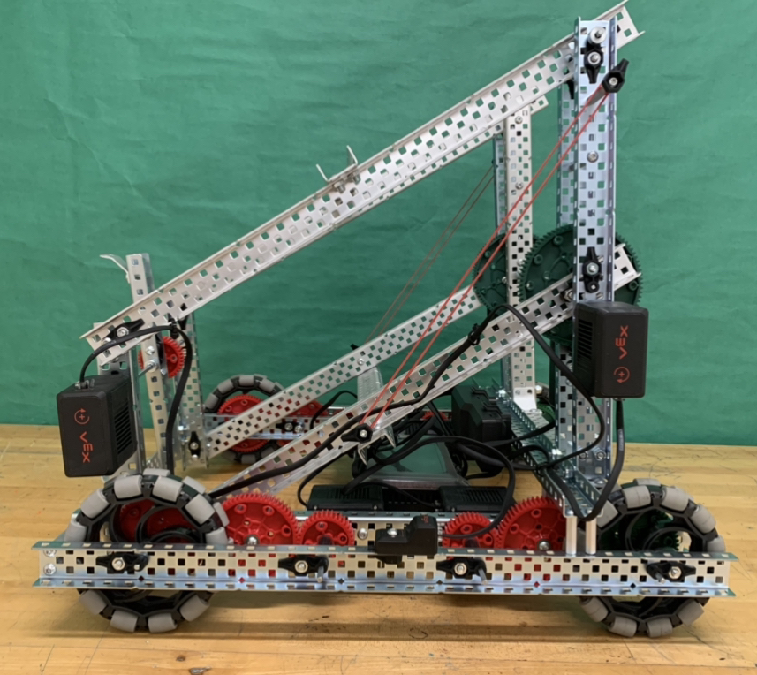

Side view of Blam Bot with its arm down.

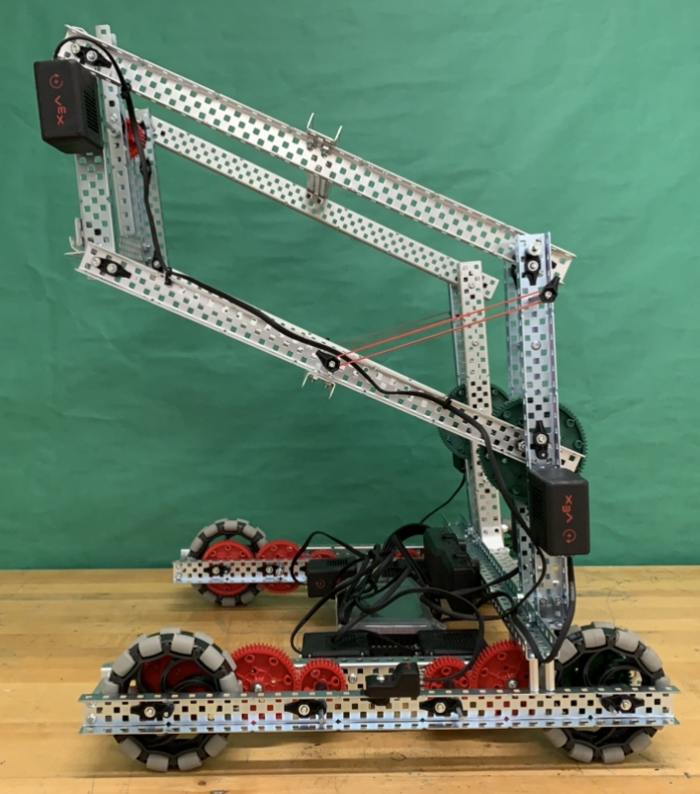

Side view of Blam Bot with its arm up.